**Case Study Report: Exploring Field Test Mode on Android Phones**

**Objective:** This case study aims to explore and understand the key networking information available on smartphones by using the Field Test Mode. As a student using an Android phone, I followed the guidelines to gather technical details about my phone's network settings and performance.

**1. Device Information:**

* **Device Type:** POCO 5G (Android Phone)
* **Operating System:** Android OS

**2. Key Network Parameters and Their Importance:**

* **IMEI Number (International Mobile Equipment Identity):**
  + The IMEI is a unique identifier for the device. It helps in tracking the device, especially for security purposes, such as in case of theft or loss. Network operators use the IMEI to authenticate and allow access to their networks.
  + *Importance:* The IMEI is essential for identifying your device on a network and ensuring it can access cellular services.
* **MAC Address (Media Access Control Address):**
  + The MAC address is a unique identifier assigned to the phone's Wi-Fi adapter. It allows the device to connect to Wi-Fi networks and is used by routers to identify each connected device.
  + *Importance:* Helps in network security and device identification on local Wi-Fi networks.
* **IP Address (Internet Protocol Address):**
  + The IP address is the numerical label assigned to the device on the internet or a local network. It enables devices to communicate with each other over the internet.
  + *Importance:* Critical for internet communication and identifying the device on a network.
* **Network Operator/Brand:**
  + The name of the cellular provider offering network services. It is crucial for understanding the source of the mobile network service.
  + *Importance:* Determines the mobile service quality and the network type (e.g., 4G, 5G) available.
* **Network Type (4G LTE, 5G, etc.):**
  + Refers to the generation and type of mobile network the device is connected to. It can indicate the speed and capabilities of the network in terms of data transmission.
  + *Importance:* Shows the network speed and efficiency, crucial for tasks like video streaming or browsing.
* **Signal Strength (Measured in dBm):**
  + Signal strength indicates the power of the network signal the phone is receiving. It is measured in decibels per milliwatt (dBm), with values closer to zero indicating stronger signals.
  + *Importance:* Determines the quality of the network connection, which affects call quality and internet speed.
* **Download/Upload Bandwidth:**
  + This refers to the speed at which data is downloaded from or uploaded to the internet. It is essential for activities like downloading files or streaming videos.
  + *Importance:* Critical for ensuring smooth internet usage and good user experience.
* **Mobile Location Information (LAC - Location Area Code and CID - Cell ID):**
  + LAC and CID represent the unique identifiers for the current mobile tower and its location. It helps determine where the device is connected to the network.
  + *Importance:* Useful in determining your current network coverage and location tracking.

**3. Steps to Access Field Test Mode:**

1. **Accessing Field Test Mode on Android:**
   * Open the phone dialer and enter *#*#4636#*#* to access the testing menu.
   * Navigate to **Phone Information** and **Wi-Fi Information** for relevant network details.
   * Took screenshots of important details like IMEI, signal strength, and network type.
2. **Details Collected:**
   * IMEI, MAC address, IP address, network type (5G LTE), signal strength, and operator information.
   * Signal strength recorded at -95 dBm, network type 5G LTE, network operator is Jio Telecom.

• **IMEI Number (International Mobile Equipment Identity):**

* IMEI: 866296064386516

• **MAC Address (Media Access Control Address):**

* **MAC Address:** 5c:a0:6c:2d:51:45

• **IP Address (Internet Protocol Address):**

* **IP Address:** 2409:40f4:305a:7841:8000::

• **Network Operator/Brand (Cellular Provider):**

* Operator: Jio True5G

• **Network Type (4G LTE, 5G, etc.):**

* Network Type: NR_SA (5G Standalone)

• **Signal Strength (Measured in dBm):**

* Signal Strength: -92 dBm

• **Download/Upload Bandwidth (Physical Channel Configuration and Speed):**

* DL Bandwidth (kbps): 35,975
* UL Bandwidth (kbps): 35,975

**4. Screenshots:**

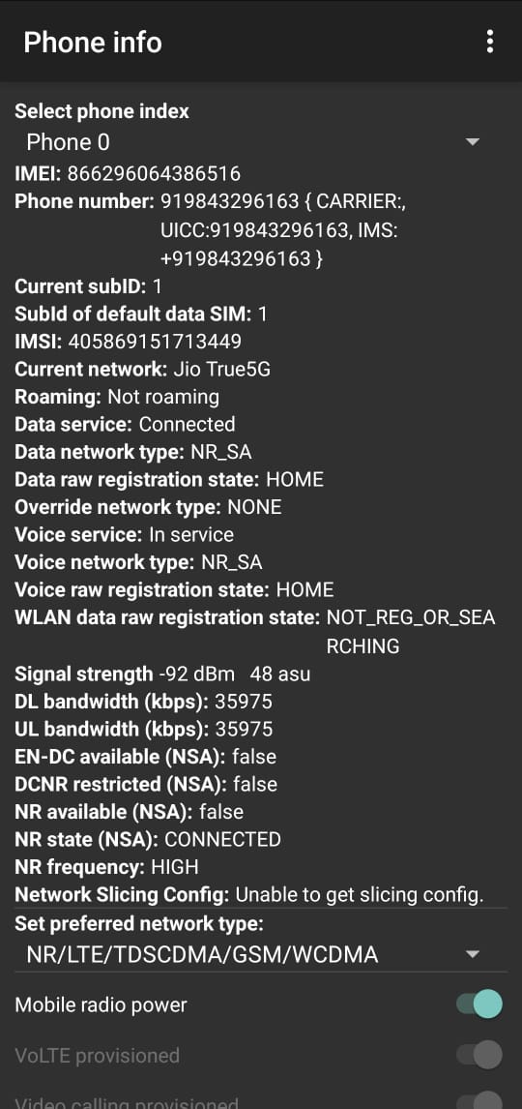

**5. Conclusion:**

By accessing Field Test Mode on my Android phone, I was able to gather critical networking details. This process enhances my understanding of mobile network performance, and the significance of parameters like IMEI, signal strength, and network type in ensuring seamless communication.

The network performance on my device was satisfactory, with moderate signal strength and a stable 5G LTE connection. These findings emphasize the importance of understanding network diagnostics to optimize device performance.

**Submission Details:**

* The report and screenshots have been uploaded to a private GitHub repository.
* The GitHub repository link was submitted via Google Classroom as required.

**References:**

1. Waveform Guide: [Field Test Mode](https://www.waveform.com/a/b/guides/field-test-guide)
2. Signal Booster Guide: [Field Test Mode](https://www.signalbooster.com/pages/field-test-mode)

Name: Lokeshwaran S

Register No.: RA2211003050166

III CSE C